1.1 Areas Between Curves

A Quick Review:

Example: Let A be the area of the region that lies above the x-axis and under the graph of between & . Estimate the area by using a Right Riemann Sum with 4 rectangles.

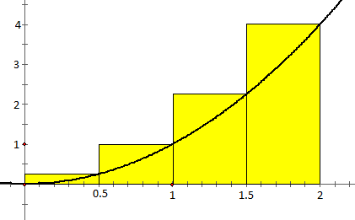

This is an overestimate of the area.

Definition: If f is a continuous function on , then the definite integral of f from a to b is
Height of
each rectangle
Width of
each rectangle
Add up the areas of $n$
rectangles
Let the number of rectangles go to $∞$

provided that this limit exists and gives the same value for all possible choices of sample points . If it does exist, we say that f is integrable on .

Areas Between Two Curves:

General Idea:

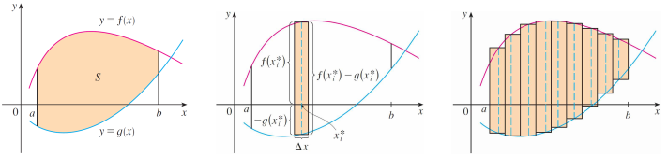

Consider the picture below that has the region S which is determined by the area between the functions and on the interval . To find this area we will use a Riemann sum by dividing the region into n intervals (which correspond to $n$ rectangles) of equal width. So we have

Where is a sample point from the ith interval. We can recognize this limit as the definite integral of .

Definition (Area Between Two Curves w/respect to x): The area A of the region bounded by the curves , and the lines , where f and g are continuous and for all x in , is

Example 1: Find the area of the region bounded by .

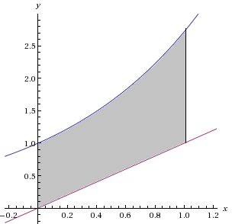
Setup:

Evaluate:

Example 2: Find the area of the region bounded by the curves .
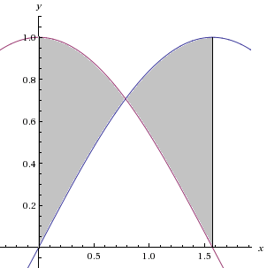
When we look at the picture we see that the “top” function changes after the intersection. We must split this problem up into two different integrals. To do this we need to find the point of intersection.

We know that on the given interval for x.
Therefore we write that:

Setup:

Evaluate:

Example 3: Find the area enclosed by the curves .

We start by finding the intersection points of the region. We see that
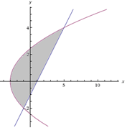
$$\left(5,4\right)$$
$$\left(-1,-2\right)$$

If , then and we have the point .
If , then and we have the point .

We notice that on the interval the parabola is the top function and the line is the bottom, however on the interval the parabola is both the top & bottom function.

At times like these it may be helpful to write the parabola as two separate functions of x or to integrate with respect to y
Integrating with Respect to y (instead of x)

General Idea:
We should note that not all curves can regarded y as a function of x. Some curves are best treated as , where x is a function of y. If we consider the picture below we can see that we can still use the idea of a Riemann sum.
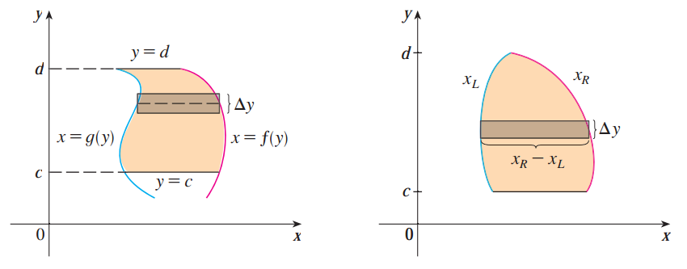

Definition (Area Between Two Curves with respect to y): The area A of the region bounded by the curves , and the lines , where f and g are continuous and for all y in , is

Example 3 (continued): Find the area enclosed by the curves .

We begin by solve our equations for x so that we can view these curves as functions of y.

We see that the linear function forms the right side of the region and the parabola function forms the left side of the region. Therefore we write the following.
$$\left(5,4\right)$$
$$\left(-1,-2\right)$$

Setup:
Evaluate:
Example 4: Find the area enclosed by the curves and the x-axis.

- Find this area by integrating with respect to y.

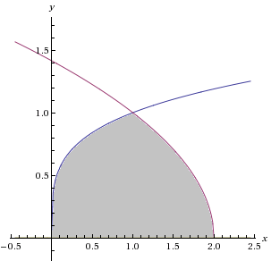
We see that the region has a right boundary of and a left boundary of . We must solve these equations for x.
$$\left(2,0\right)$$
$$\left(0,0\right)$$
$$\left(1,1\right)$$

We also find the intersection points of these curves.

So clearly we have an intersection point at . Therefore we have:

Setup:

Evaluate:

- Find this area by integrating with respect to x.

$$\left(2,0\right)$$
$$\left(0,0\right)$$
$$\left(1,1\right)$$
This approach will require 2 integrals since top boundary changes when . The bottom boundary is always .

Setup:

Evaluate:
Let and thus .
Our limits of integration become: . So we have:

